A Major Project Phase 1- B Report On
DermaClust: A Multimodal, Severity-Calibrated Neural Paradigm for Skin Morphological Disparity Modeling and
Cross-Domain Product Vector Synthesis via
Biometric-Gated Access
Submitted in partial fulfilment of the degree of
Bachelor of Technology in Computer Science and Technology
Submitted by
Dhairya Bandekar (03)
Bhavika Patil (43)
Priyanshu Yadav (69)

Under the guidance of
Prof. Prajakta Gotarne
USHA MITTAL INSTITUTE OF TECHNOLOGY
S.N.D.T WOMEN’S UNIVERSITY
MUMBAI – 400049

2025–2026

CERTIFICATE
This is to certify that Dhairya Bandekar, Bhavika Patil, and Priyanshu Yadav have completed their A Major Project Phase 1-B Report titled “DermaClust: A Multimodal, Severity-Calibrated Neural Paradigm for Skin Morphological Disparity Modelling and
Cross-Domain Product Vector Synthesis via Biometric-Gated Access” in partial fulfilment of the Bachelor’s degree in Computer Science and Technology during the academic year 2025–26, as prescribed by SNDT Women’s University.

Prof. Prajakta Gotarne Prof. Kumud Wasnik
Guide H.O.D

Dr. Yogesh Nerkar
Principal

Examiner 1 Examiner 2

Acknowledgement

We would like to express our sincere appreciation to everyone who contributed to this project. Special thanks to our guide, Prof. Prajakta Gotarne for her invaluable guidance and constant support. We also extend our gratitude to the Head of Department, faculty members, and our classmates for their encouragement and constructive feedback.
Finally, we thank our families for their unwavering support.

Contents
1 Abstract 4
2 Introduction 5
2.1 Problem Statement 7
3 Literature Survey 8
4 Systems 10
4.1 Existing System 10
4.2 Proposed System 11
5 Architecture Overview 14
5.1 Architecture Overview 14
6 System Requirements 16
7 Project Implementation 17
8 Result & Analysis 18
9 Future Scope 20
10 Conclusion 21
11 References 22

Chapter 1

Abstract
The skincare industry has witnessed rapid growth, offering a vast range of cosmetic products designed to target diverse skin concerns. While this variety empowers consumers with multiple choices, it also creates confusion in identifying products that best suit their unique requirements. Traditional recommendation systems rely on reviews, ratings, demographics, or purchase history, but these approaches often fail to consider two crucial aspects: the scientific composition of cosmetic ingredients and the dynamic, real-time condition of the user’s skin. To address this challenge, we propose DermaClust, an intelligent skincare recommendation system that integrates deep learning-based ingredient analysis with real-time facial skin scanning. The system employs a BERT-based model to interpret ingredient lists and a U-Net segmentation model to detect skin concerns such as acne, dryness, pigmentation, and wrinkles from live webcam input. By combining scientific understanding of formulations with adaptive skin condition evaluation, the system generates highly personalized product recommendations. This dual approach not only enhances accuracy but also ensures responsiveness to changing skin health, bridging the gap between cosmetic science and AI-driven personalization. Results demonstrate that incorporating both ingredient-level insights and real-time skin analysis significantly improves the prediction of product suitability, offering a robust, user-centric solution for evidence-based skincare guidance. Keywords: DermaClust, cosmetic
recommendation, deep learning, real-time face scanning, skin analysis, ingredient analysis

Chapter 2

Introduction
The global cosmetic and skincare industry has grown at an extraordinary pace over the past decade, with new brands and products being launched almost every day. While this expansion has created more choices for consumers, it has also introduced a significant challenge: navigating the overwhelming variety of skincare products to find those that genuinely address individual needs. Consumers are often influenced by marketing claims, online reviews, and social media trends, which may not always align with scientific evidence or their unique skin characteristics. This often leads to a trial-and-error approach, where users purchase multiple products before finding one that suits them, resulting in wasted resources and frustration. Recommendation systems have emerged as powerful tools to simplify decision-making across industries, including e-commerce, entertainment, and healthcare. In skincare, however, most existing systems rely on superficial information such as ratings, purchase history, or demographic data. While useful to some extent, these methods overlook two critical factors that largely determine skincare effectiveness: the ingredient composition of cosmetic products and the real-time condition of the user’s skin. Skincare efficacy is inherently dependent on the active compounds present in a formulation, their concentrations, and their compatibility with specific skin types. Similarly, skin is a dynamic organ whose condition changes daily based on factors such as climate, stress, lifestyle, and pollution exposure. Systems that ignore these factors fail to deliver meaningful personalization and risk recommending products that are ineffective or even harmful.
Understanding ingredient composition is essential because skincare products are primarily defined by their formulations. Ingredients such as salicylic acid, hyaluronic acid, retinol, and niacinamide are known to target acne, hydration, aging, and pigmentation, respectively. However, ingredient labels are often complex, using technical or chemical terminology that is difficult for the average consumer to interpret. Furthermore, the sequential arrangement of ingredients plays a vital role, as the order reflects their relative concentrations, which directly impacts the effectiveness of the product. Traditional recommendation systems are not equipped to handle such structured yet complex data. To overcome this limitation, the proposed system incorporates natural language processing techniques, particularly a BERT-based deep learning model, to analyze ingredient lists with contextual understanding. This enables the system to assess formulations in a scientifically meaningful way rather than relying solely on product tags or descriptions. Equally important is the real-time analysis of the user’s skin condition. Unlike static data such as skin type or medical history, real-time evaluation provides a snapshot of the skin’s current health, which can vary significantly even within short time frames. For example, a person with generally oily skin may experience dryness during colder months or develop acne due to stress and diet changes. Capturing these variations is essential for providing recommendations that remain relevant and effective. To achieve this, the system leverages computer vision techniques through a U-Net based segmentation model that processes live webcam input. This enables the dynamic detection of concerns such as acne, dryness, wrinkles, and pigmentation, ensuring that recommendations evolve alongside the user’s skin condition.
The innovation of DermaClust lies in its ability to combine these two complementary approaches—ingredient-level analysis and real-time skin evaluation—into a single recommendation framework. For instance, if a live scan detects dryness, the system prioritizes products enriched with moisturizing agents such as ceramides and hyaluronic acid. Conversely, if acne is detected, it highlights products containing salicylic acid while avoiding comedogenic ingredients that may worsen the condition. This synergy between ingredient science and adaptive skin assessment allows for more reliable and evidencebased recommendations compared to existing systems.
The ultimate objective of DermaClust is to create a user-centric, intelligent skincare assistant that simplifies product selection, enhances accuracy, and improves user trust. By bridging the gap between cosmetic science and artificial intelligence, the system not only supports consumers in making informed decisions but also opens new opportunities for the cosmetic industry to engage users in a more personalized and scientifically grounded manner. As skincare continues to be an integral part of self-care and wellness, integrating AI-driven personalization ensures that consumers receive tailored guidance aligned with their evolving skin health, thereby setting a new standard for intelligent skincare recommendation systems.

2.1 Problem Statement
Most skincare recommendation systems fall short of providing scientifically validated guidance, relying instead on marketing claims, brand popularity, and subjective user reviews. This leaves users navigating a confusing mix of conflicting information that often ignores their unique skin types and concerns. The lack of evidence-based personalization can result in ineffective outcomes, unsuitable purchases, or even adverse reactions from incompatible formulations, reducing user trust and highlighting the need for more reliable, science-driven solutions.
To bridge this gap, this project introduces an AI-powered skincare recommendation system that combines real-time facial skin scanning with deep ingredient-level evaluation. Using U-Net for skin segmentation and live webcam input, the system detects conditions such as acne, dryness, pigmentation, and wrinkles, while a BERT-based model interprets ingredient sequences to assess product formulations. By aligning dermatological insights with real-time skin profiles, the system delivers accurate, safe, and personalized product suggestions. This dual approach enhances reliability and promotes preventive skincare, offering a robust, evidence-based innovation in cosmetic recommendations.

Chapter 3

Literature Survey
Over the years, several approaches have been proposed for skincare product recommendation systems, each leveraging different algorithms and focusing on unique aspects of
personalization.
In 2022, a study on Facial Skincare Products’ Recommendation with Computer Vision Technologies utilised SVM, DeepLab-v3+, Haar DWT, and Gabor Filters. The system integrated finger-vein ID and computer vision for skin type and acne-based product recommendations. While it achieved promising accuracies—up to 94% for skin type and about 80% for acne detection—it was limited to a narrow age range (18–23 years) and relied on selflabelled acne data. Moreover, the absence of weather or emotional input data restricted the robustness of the recommendations.
Another2022 study adopted a Collaborative Filtering Approach using Singular Value Decomposition (SVD) and ALS for product recommendation. By analysing user-product rating data from FemaleDaily, it could predict personalised recommendations. However, this method ignored crucial factors such as skin type and environmental influences, depending solely on rating matrices. As a result, its performance was modest, with an accuracy of around 74.7% (RMSE = 1.01276 on a 1–5 rating scale).
In 2024, research shifted towards Deep Learning-Based Skincare Product Recommendation, employing Transformer Encoders and U-Net architectures. This method combined ingredient analysis with facial skin condition detection for tailored suggestions. It achieved strong accuracies (90% for ingredient analysis and 84% for the skin analyser). Despite this, the system struggled with limited generalisation due to imbalanced datasets and inconsistencies in ingredient information, highlighting the importance of dataset quality and diversity.
Most recently, in 2025, a Skincare Recommendation System Based on Facial Skin Type with
Real-Time Weather Integration was developed. Leveraging ResNet50 (CNN), Decision Trees, and MTCNN, this work emphasised the integration of external factors such as weather conditions into skincare personalisation. With an accuracy of 90.94%, it demonstrated that combining facial skin type classification with contextual weather data improved recommendation relevance. However, the dataset used lacked demographic diversity, and the weather classification employed was relatively simplistic.
Overall, these studies demonstrate a gradual progression from traditional machine learning approaches toward deep learning and hybrid models that integrate contextual factors. While accuracy has improved significantly, limitations remain regarding dataset diversity, generalisation ability, and inclusion of real-world variables such as environment and lifestyle.

Literature Review Summary:
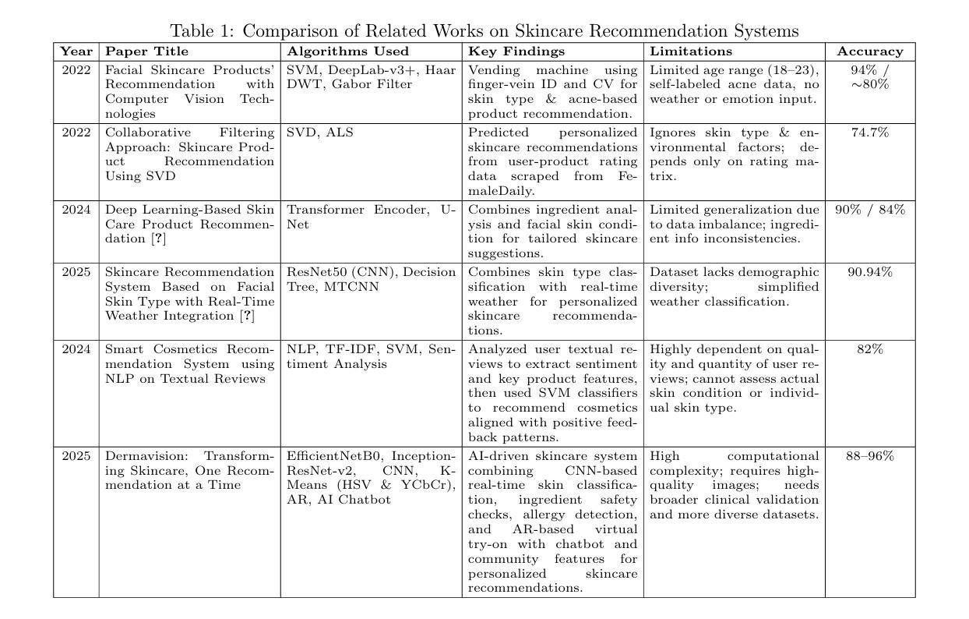
Figure 3.1: Literature Review Summary

Chapter 4

Systems

4.1 Existing System
The existing version of DermaClust provides skincare recommendations by combining facial skin analysis with ingredient-level evaluation. The step-by-step workflow is as follows:

1. Image Input and Preprocessing
- Users upload facial images for analysis.
- Images are resized, normalized, and aligned to ensure consistency and robustness in model predictions.

2. Skin Concern Detection using U-Net
- A U-Net based segmentation model analyzes the uploaded images.
- It classifies regions of the face into different categories:
  - Acne
  - Pigmentation
  - Wrinkles
  - Dryness
  - Normal skin
- Segmentation masks are generated for each concern.
- From these masks, severity scores are calculated based on the proportion of af- fected regions.
- The output is a user concern vector representing the intensity of each skin issue.

3. Ingredient Data Collection and Preprocessing
- Skincare product ingredient lists are collected and standardized.
- Synonyms and chemical variations are normalized.
- The order of ingredients is preserved as it reflects concentration levels.

4. Ingredient Analysis using BERT
- A BERT-based NLP model interprets ingredient lists.
- It predicts the effectiveness of each product against concerns like acne, dryness, pigmentation, and wrinkles.
- The result is a product concern vector indicating the suitability of the product for different skin conditions.

5. Recommendation Generation
- The user concern vector (from image analysis) is compared with the product concern vectors (from ingredient analysis).
- Cosine similarity is used to determine how well each product matches the user’s skin
profile.
- Products are ranked according to similarity scores.
- Safety checks are applied to exclude products with harmful or incompatible ingre- dients.

6. User Interface (Streamlit-based)
- An interactive Streamlit interface allows users to upload images and view results.
- Skin analysis results are displayed with segmentation overlays.
- Recommended products are shown with explanations, including detected concerns and key ingredient matches.

7. System Outcome
- Delivers personalized, evidence-based skincare recommendations.
- Ensures transparency by linking product suggestions to both skin analysis and ingredient insights.
Builds user trust by prioritizing scientific validation over marketing-driven recommendations.

4.2 Proposed System
The proposed DermaClust system advances beyond traditional skincare recommendation approaches by integrating real-time facial skin scanning with deep ingredientlevel evaluation.
The step-by-step workflow is as follows:

1. Image Acquisition (Webcam + Upload Option)
• Users can either upload a facial image or use their webcam for real-time scanning. The webcam module continuously captures facial frames to assess the skin’s current, dynamic condition.

2. Image Preprocessing
- Captured/uploaded images are aligned, resized, and normalized.
- Noise reduction and lighting adjustment techniques improve robustness.

3. Skin Concern Detection using U-Net
- A U-Net based segmentation model processes the input image(s).
- It detects and highlights major concerns:
  - Acne
  - Pigmentation
  - Wrinkles
  - Dryness
  - Normal skin
- Segmentation masks are generated, and severity scores are calculated.
- For webcam input, the system performs real-time severity updates to reflect changing skin conditions.

4. Ingredient Data Collection and Preprocessing
- Ingredient lists of skincare products are collected from reliable sources.
- Synonyms and variants are normalized for consistency.
- The sequence of ingredients is preserved to account for concentration order.

5. Ingredient Analysis using BERT
- A BERT-based NLP model encodes and analyzes ingredient lists.
- It evaluates the effectiveness of products against specific concerns like acne, pigmentation, wrinkles, and dryness.
- This generates a product concern vector for each item.

6. Recommendation Generation
- The user concern vector (from U-Net analysis) is compared with product concern vectors (from BERT analysis).
- Cosine similarity is used to measure compatibility between skin condition and product formulation.
- Products are ranked by similarity and filtered for harmful/incompatible ingredients.

7. Dynamic Real-Time Personalization
- With webcam scanning, recommendations update dynamically based on live skin
condition.
- This ensures the system adapts to environmental influences (e.g., hydration levels, lighting, fatigue).

8. User Interface (Streamlit-based)
- The Streamlit interface provides both image upload and real-time webcam scanning options.
- Users receive visual overlays of skin segmentation results.
Recommended products are displayed with concern-specific justifications and key ingredient highlights.

9. System Outcome
- Provides scientifically validated, personalized skincare recommendations.
- Bridges the gap between dermatological science and AI-driven recommendation systems.
Ensures transparency, adaptability, and user trust by combining real-time scanning with ingredient intelligence.
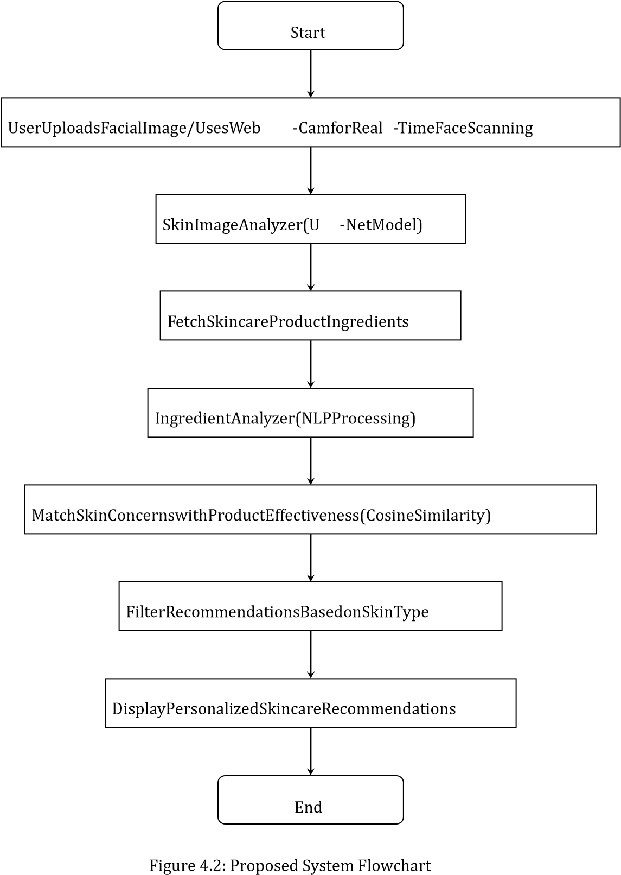

Chapter 5

Architecture Overview
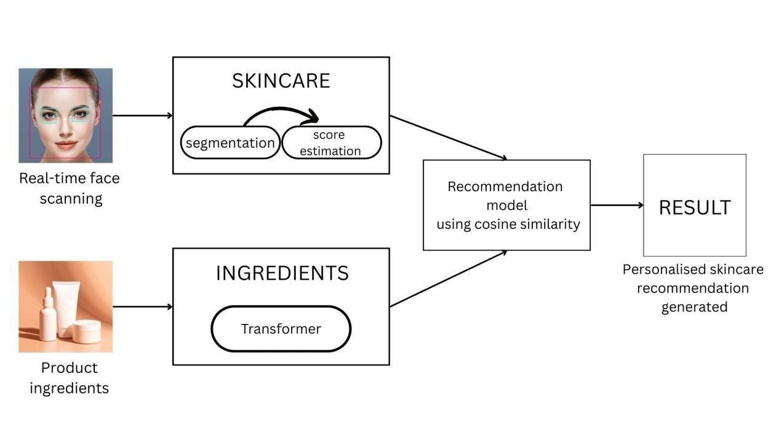
Figure 5.1: Architecture of Proposed System

5.1 Architecture Overview
The architecture of the proposed system, DermaClust, is designed to combine real-time biometric analysis with ingredient-based product evaluation for accurate skincare recommendations. The system is composed of two major modules—Real-Time Face Scanning (Skin Analyzer) and Ingredient Analyzer—which interact through a
similaritybased matching framework.
The process begins at the user interface layer, built using Streamlit, where the user uploads their facial image or activates the webcam for real-time scanning. The captured image is processed by the Skin Analyzer module, which employs a U-Net–based segmentation model to detect and quantify skin concerns such as acne, wrinkles, pigmentation, and under-eye bags.
The output of this module is represented as a concernseverity vector, where each dimension corresponds to a skin issue and its intensity. Parallelly, the Ingredient Analyzer module processes the ingredient lists of skincare products using a transformer-based deep learning model. This module encodes each product into a concern-suitability vector, mapping how well a product addresses specific skin issues.
Both the concern-severity vector (from the skin analyzer) and the concern-suitability vector (from the ingredient analyzer) are then passed to a cosine similarity engine, which computes the closeness between the user’s skin profile and product profiles. The product with the highest similarity score is recommended to the user.
This architecture ensures that recommendations are not only based on biometric skin condition but also validated against the scientific formulation of skincare products. By integrating these
components, DermaClust achieves personalized, evidence-based, and real-time
recommendations that surpass the limitations of existing systems.

Chapter 6

System Requirements

Software Requirements
- Programming Language: Python
- Operating System: Windows
- Library: OpenCV for image processing
- Database: MySQL
- Frontend Development: Streamlit
- Development Environment: Jupyter Notebook / VS Code / PyCharm

Hardware Requirements
- Processor: Intel i5/i7 (10th Gen+) or AMD Ryzen 5/7
- RAM: Minimum 8GB (Recommended: 16GB) • GPU: NVIDIA GTX 1650 / RTX 2060+
- Storage: 256GB SSD (512GB recommended)
- Internet: Required for cloud training & APIs

Chapter 7

Project Implementation

Implementation Steps
- Data Collection and Preprocessing
Skincare ingredient datasets and facial skin images were collected from public repositories and dermatology sources. Ingredient data was tokenized and normalized, while images were resized, normalized, and augmented.
- Ingredient Analyzer Development
A BERT-based NLP model was used to analyze skincare ingredients.
Ingredient listswere converted into embeddings representing skin concerns (acne, oily, dry, wrinkles, normal). The model was trained using labeled ingredient– concern mappings.
3. Skin Concern Analyzer (Face Scanning)
A U-Net segmentation model was implemented to detect acne, wrinkles, pigmenta-
tion, and eye bags from facial images. Real-time webcam input was integrated to allow live face scanning.
- Cosine Similarity-based Recommendation Engine
Ingredient embeddings were compared with skin concern embeddings using cosine
similarity to recommend the most suitable products.
- Frontend Development (User Interface)
A Streamlit-based interface was developed where users can upload images,
scanfaces in real-time, and input ingredient lists. The interface displays personalized
recommendations.
- System Integration
The ingredient analyzer, face scanning module, and recommendation engine were integrated into a single pipeline, ensuring smooth communication between frontend and backend.
- Testing and Validation
The system was tested on multiple datasets and validated across different skin types. Performance improvements were made using early stopping, learning rate scheduling, and checkpointing.
Chapter 8

Result & Analysis

Capturing Face in Real-time-
The system successfully captures the user’s face in real time through the webcam for instant
skin concern analysis.
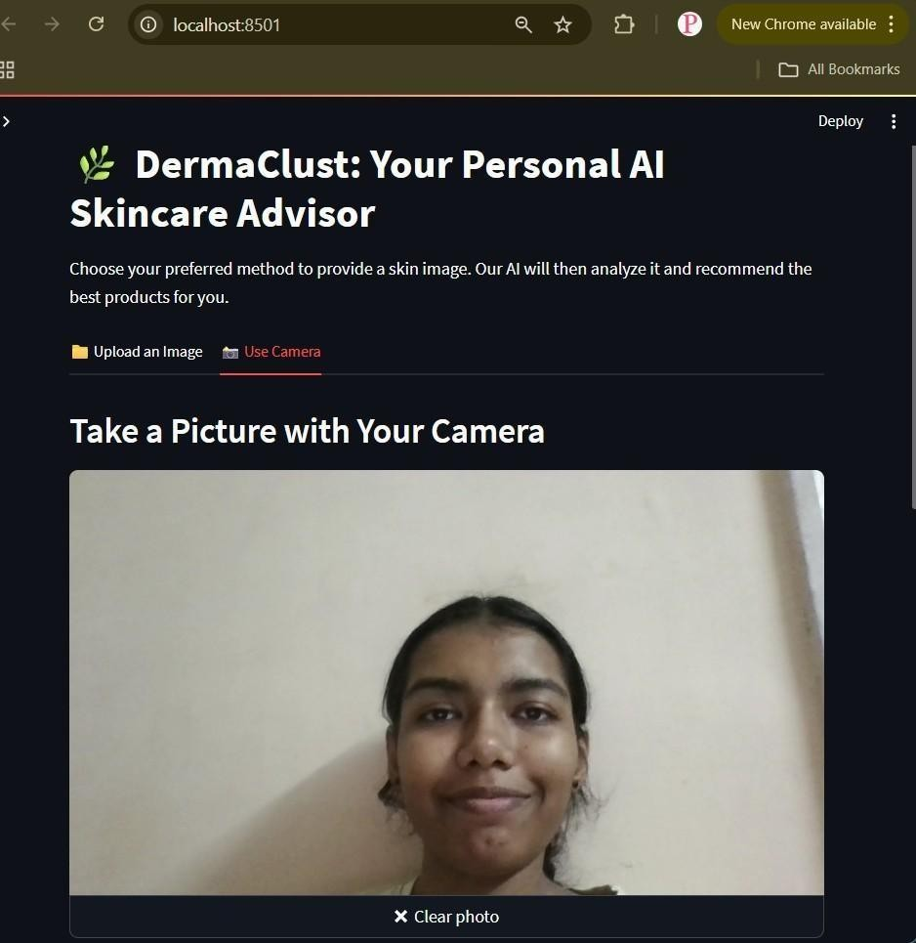
Figure 8.1: Real-time face scanning
The system displays the captured facial image to confirm successful input before processing for skin concern analysis.

Skin Concern Segmentation and Ingredient Analysis with Final Product Recommendations-
The system performs skin concern segmentation on the captured image, analyzes product ingredients using the NLP-based model, and generates final product recommendations tailored to the user’s skin condition.
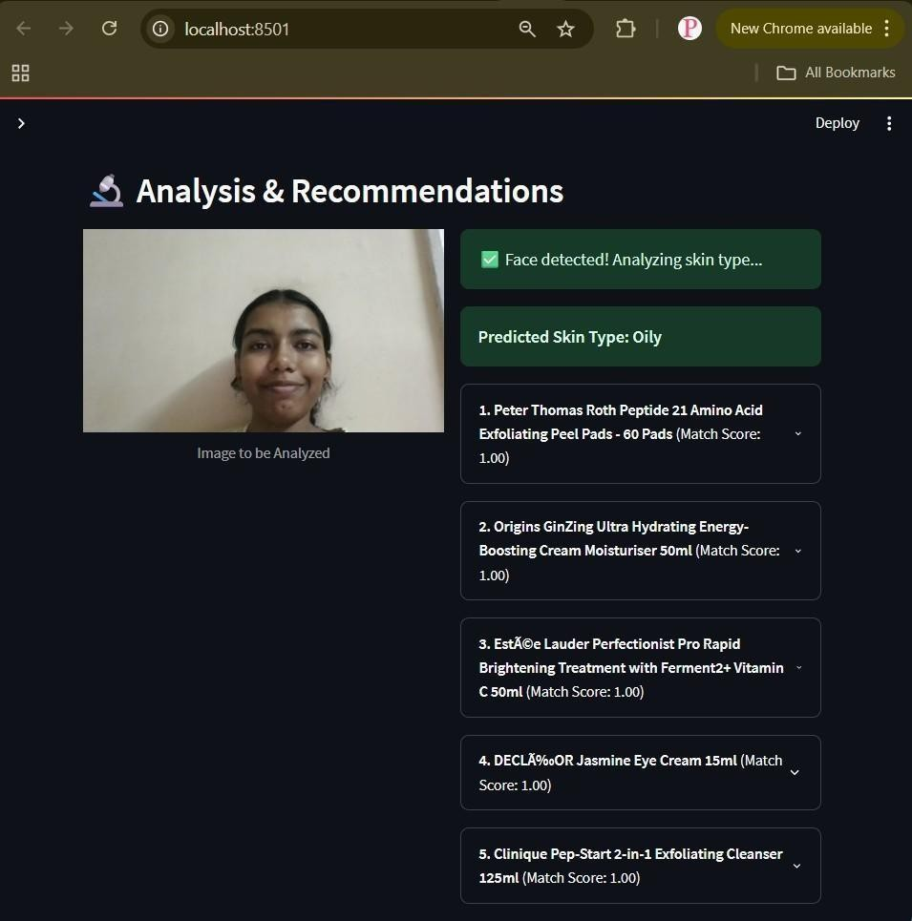
Figure 8.2: Final Product Recommendations

Chapter 9

Future Scope
The current system provides skincare recommendations by analysing ingredients and real-time face scanning. Future enhancements can make the system more intelligent and
user-friendly:
- Weather-based Product Recommendation – Integration of a Weather API to adapt skincare suggestions based on temperature, humidity, and pollution. For example,
hydrating creams in dry weather and oil-control products in humid climates.
- Biometric Authentication – Adding face recognition or fingerprint scanning for secure
and personalised access, ensuring data privacy.
- Mobile Application Development – Extending the system into a mobile app for Android/iOS so users can scan skin and receive recommendations instantly.
- Cloud Deployment and Scalability – Hosting on AWS, IBM Cloud, or Azure to support
real-time multi-user recommendations with improved scalability.
- Integration with Wearables – Connecting with smartwatches or skin sensors to monitor
hydration, UV exposure, and environmental stressors for proactive recommendations.

Chapter 10

Conclusion
The proposed skincare recommendation system successfully integrates ingredient analysis and real-time facial skin scanning to provide personalised product suggestions. By leveraging deep learning models such as BERT for ingredient understanding and UNet for skin concern segmentation, the system ensures scientifically grounded recommendations rather than relying solely on marketing claims or subjective reviews. The incorporation of a cosine similaritybased recommendation engine allows meaningful alignment between skincare product
ingredients and individual skin conditions. Furthermore, the Streamlit-based user interface provides an intuitive platform where users can easily scan their face, analyse skin concerns, and input product details to receive accurate recommendations.
Overall, the system demonstrates the potential of combining natural language processing and computer vision for practical applications in dermatology and cosmetology. With further enhancements such as weather-aware recommendations, biometric authentication, and mobile deployment, the solution can evolve into a comprehensive, scalable, and an intelligent skincare advisory platform.

Chapter 11

References
- Rao, N. Y. N. (2025). Skin Type Profiling through Computer Vision and NearestNeighbour Methods...
- Lee, J., Yoon, H., Kim, S., et al. (2024). Deep learning-based skin care
productrecommendation...
- Du Crest, D., Wustrow, P., et al. (2024). Skin & Digital – The 2023 Startups / Innovators...
- Putriany, V., Jauhari, J., & Heroza, R. I. (2019). Item Clustering as An Input...
- Miryabbelli, J., AVN Institute of Engineering and Technology, et al. (2024).
SmartCosmetics Recommendation System...
- A natural language processing approach to a skincare recommendation engine -
NORMA@NCI Library. (n.d.)

